Week 6
Problem 1
Using google collab I loaded an image of bondi beach. This was through the use of the matpilotlib and keras packages that come preinstalled on collab. I did have to insert my own image in place of the link provided.
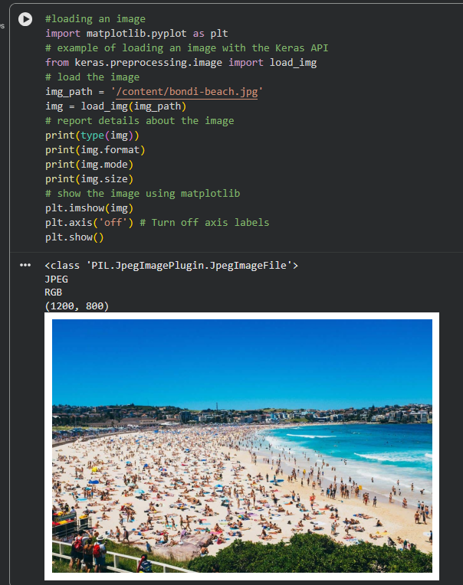

Problem 2
Here we convert that same image to a numpy array using img_array.
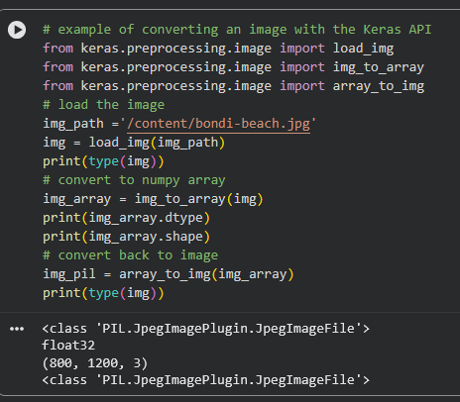
Problem 3
Here we convert the image to greyscale by adjusting the colour mode. We then save it into a folder we created called Images.
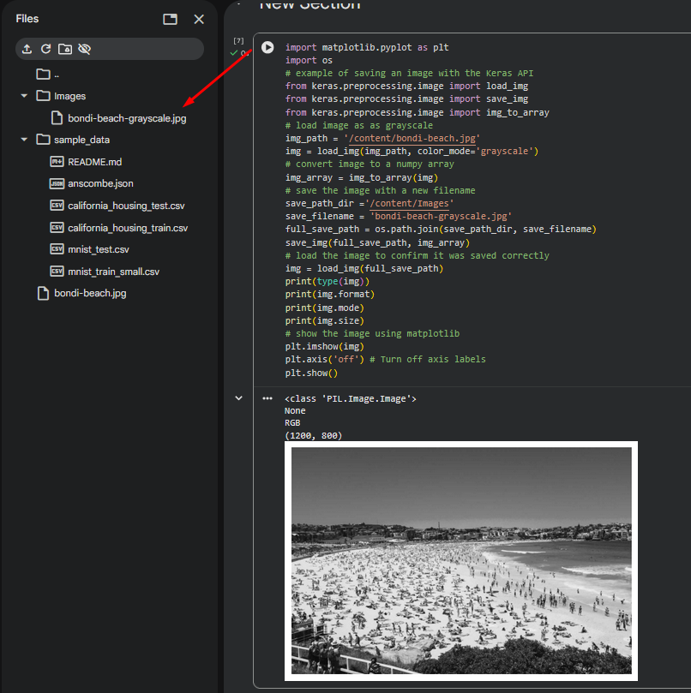

Problem 4
Here we load a pre-existing image dataset from Kera and summarise it.
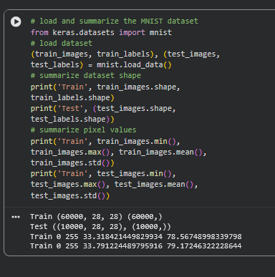

Problem 5
Here we normalise an images dataset to
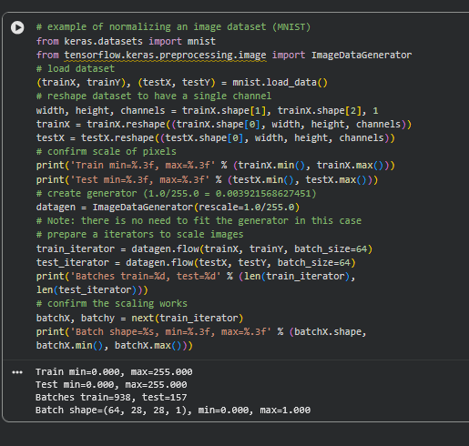
Problem 6
Here we centre an image dataset
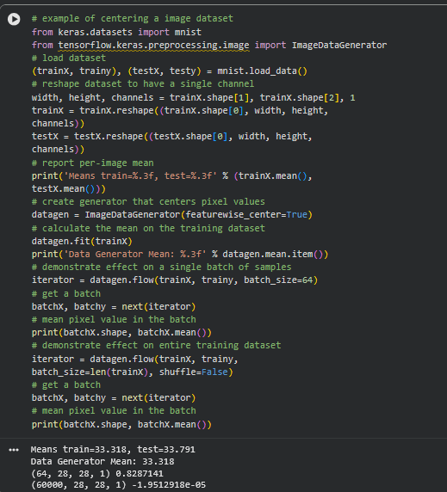
Problem 7
Here we standardise an image dataset
